Use this form to request new group members, or changes to existing group members. Complete the following steps:

- Fill in the fields in the appropriate section below to add a new group member or change an existing group member.
- Go to the 3C Hotline and open a ticket, attach this file, and submit the ticket. (See page 2 for directions)
- You will be notified of the status of the group member add/change via the ticket

Provider/Agency Name:
Indicate if this request is to “ADD NEW” or “CHANGE” | ☐ ADD NEW ☐ CHANGE
Program this applies to:
Group Member Start Date:

Request to ADD NEW Group Member
Enter your information in the last column. Some information is already filled out for you as it is the default value.
Field Name | Criteria | Enter your details here:
Last Name | The first 30 characters of the Program Name
First Name | Session number (e.g. Session 1, Session 2, etc.)
Address Street 1 | Name of the School, Community Center, Religious Institution, etc. Where Program is Held
Address Street 2 | Address of Where Program is Held
Address Street 3 | Additional address of Program Site if needed.
Address City | City Where Program is Held
Address State | OH
Address Zip | Zip Code Where Program is Held

Request to Change Existing Group Member
Enter the information that you would like changed; list both the current value and proposed value. It is assumed that if you leave a field in the table below blank that you do not want it changed for the group member.
Field Name | Please enter Current value: | Enter what is changing here:
SHARES ID | (required) | (cannot be changed)
Last Name
First Name
Address Street 1
Address Street 2
Address Street 3
Address City
Address Zip

THIS SECTION FOR ADAMH USE ONLY:
Allocation Line: |  | Phaseware Ticket #
Prevention/Treatment? |  | Date Completed:
Note: If you are unfamiliar with how to submit a 3C Hotline ticket, you can access the instructions from the Provider Portal (http://www.adamhfranklin.org/provider-portal/). Contact sduderstadt@adamhfranklin.org to request a password reset if needed.

Sample of the information to choose when submitting a ticket for adding/changing group members using the 3C Hotline:
1. Log into https://tracker.phaseware.com/3CHelpdesk
2. Click on “Submit New Ticket”
3. Enter the information similarly as shown in this sample ticket below:
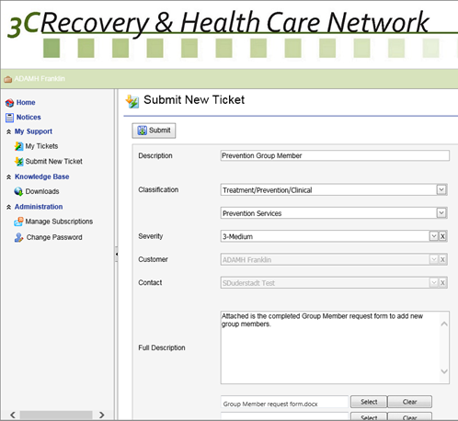
Select “Prevention Services” from the sub dropdown.

Select “Treatment/Prevention/Clinical” from the Classification dropdown.

Enter the description as “Prevention Group Member”.

Select your completed “Group Member Request Form” file and attach.

Enter any additional information into the body of the ticket if necessary.

When done, click on the “Submit” button to submit your ticket

Following these steps will ensure that your ticket is routed to the proper Board staff. You will receive email updates when notes are added to your ticket, and you will receive an email notice when the ticket is closed. You can log into the 3C Hotline to access your ticket and read the notes at any time.

