**Description:** Re-adjudication Request - The purpose of this document is to offer ADAMH provider agencies detailed instructions regarding when and how to request a claim re-adjudication.

**Instructions:** For circumstances requiring that a claim be reprocessed through the adjudication process, please use the following instructions to submit a request for claim re-adjudication:

1. The first step is to prepare an excel file with the claims that need re-adjudicated by using information from the Adjudication Status Detail report. The Adjudication Status Detail report can be accessed from SHARES by going to **File Transfer** and choosing **Download**.

**C:\Users\sduderstadt\AppData\Local\Microsoft\Windows\Temporary Internet Files\Content.IE5\5K9NNDC3\one-38484_640[1].png**

C:\Users\sduderstadt\AppData\Local\Microsoft\Windows\Temporary Internet Files\Content.IE5\16A52832\two-39115_640[1].png 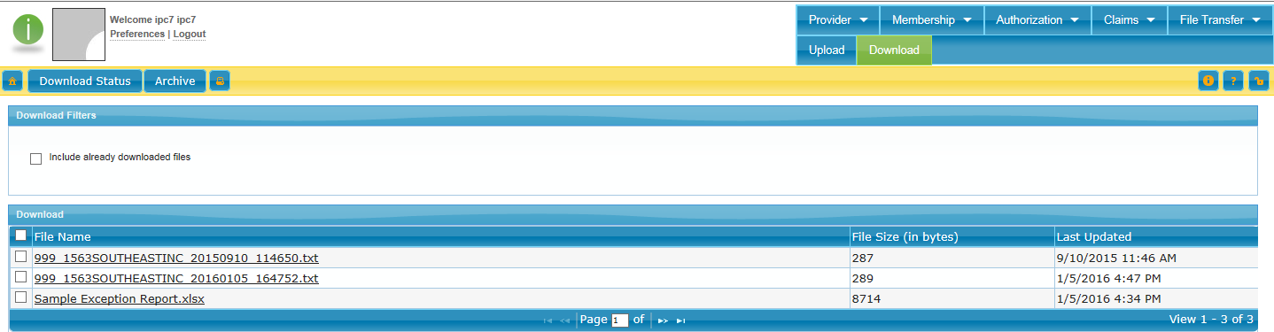

1. Information must be removed from the Adjudication Detail report to ensure that PHI is not shared. **Make sure to only include the claims from that report that should be re-adjudicated.**
   1. Remove columns F (Last name) through AC (Other Diagnosis)

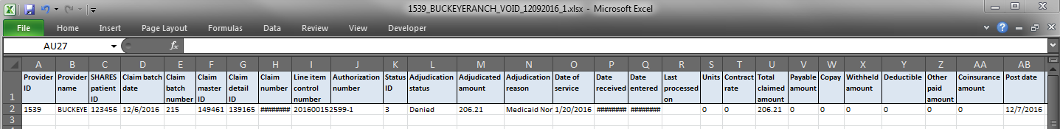

* 1. Save the file using the following naming convention:

Provider ID\_Provider name\_Re-adjudicate\_Submission Date(mmddyyyy)\_Sequence Number

*Example:**1539\_BUCKEYERANCH\_Re-adjudicate\_09302016\_1*

1. The 2nd step is to submit the file via 3C Hotline ticket by logging into the 3C Hotline and choosing “Submit New Ticket”.

Fill out the ticket as such:

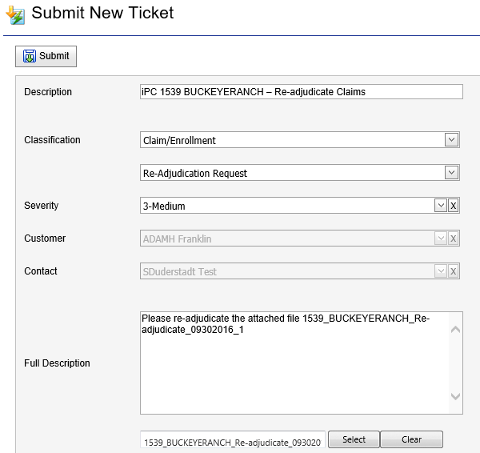

1. Enter the description as iPC #### (Provider ID) – Re-adjudicate Claims

*Example:*

*iPC 1539 BUCKEYERANCH – Re-adjudicate Claims*

1. Choose the Classification category **Claim/Enrollment, Re-adjudication Request**
2. Enter the Full Description as: **“Please re-adjudicate the attached file (*include file name*)”**
3. Browse to select the file created from the Adjudication Status Detail report to attach it to the ticket.
4. When finished, click “Submit” to submit the ticket.

After the ticket has been submitted the claims will appear on a new adjudication detail report showing the new status.

The 3C Hotline ticket will be updated to indicate the issue is resolved.