**Description:** Voiding claims - The purpose of this document is to offer ADAMH provider agencies detailed instructions regarding when and how to void a claim.

**Instructions:** After a claim has been adjudicated through SHARES it will receive one of four claims statuses (approved, accepted, denied and pending). To remove approved or accepted claims from SHARES providers must submit a void request.

1. Claims details can be reviewed on the Adjudication Status Detail report. The Adjudication Status Detail can be accessed from Provider Connect by going to **File Transfer** and choosing **Download**.

**C:\Users\sduderstadt\AppData\Local\Microsoft\Windows\Temporary Internet Files\Content.IE5\5K9NNDC3\one-38484_640[1].png**

C:\Users\sduderstadt\AppData\Local\Microsoft\Windows\Temporary Internet Files\Content.IE5\16A52832\two-39115_640[1].png 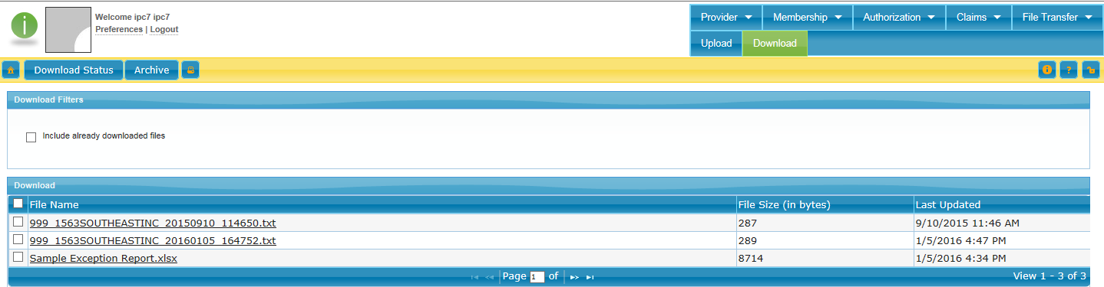

1. Information must be removed from the Adjudication Detail report to ensure that PHI is not shared. **Make sure to only include the claims from that report that should be re-adjudicated.**
   1. Remove columns F (Last name) through AC (Other Diagnosis)
   2. Remove columns C (Tax ID) and D (NPI #)

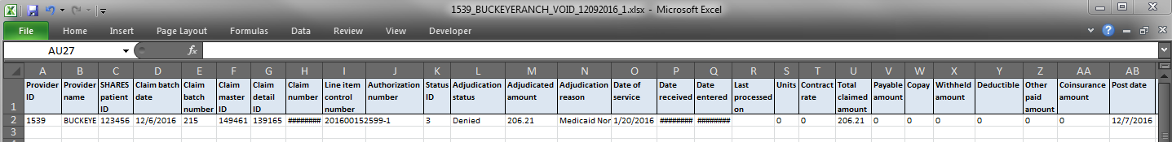

* 1. Save the file using the following naming convention
     1. Provider ID\_Provider name\_VOID\_Submission Date(mmddyyyy)\_Sequence Number
     2. Example*1539\_BUCKEYERANCH\_VOID\_09302016\_1*

1. The 2nd step is to submit the file via 3C Hotline ticket by logging into the 3C Hotline and choosing “Submit New Ticket”.

Fill out the ticket as such:

**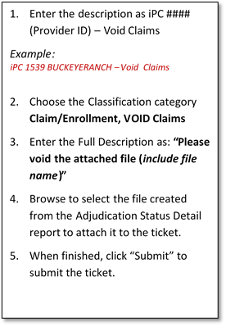******W:\Documentation\z_templates\1.png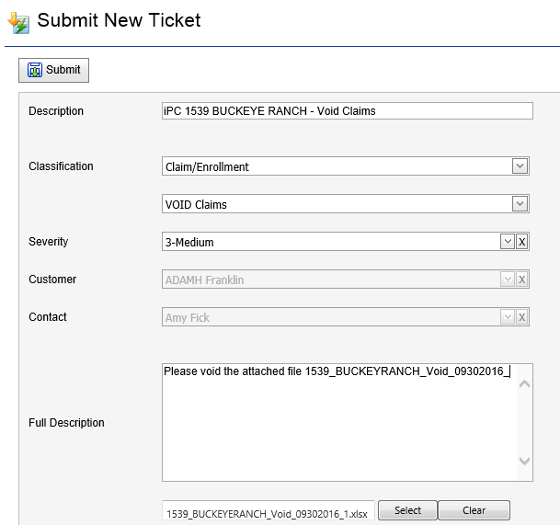

After the ticket has been submitted the void will be processed and a file will be placed in your download folder in SHARES. The file will include two columns after Post Date to indicate changes were made.

* Column Name - Updated Claim Status – Value “VOID”
* Column Name - Updated Claim Status Date – Value “Void Date”

The 3C Hotline ticket will be updated to indicate the issue is resolved. The provider can now resubmit the correct claim for processing.