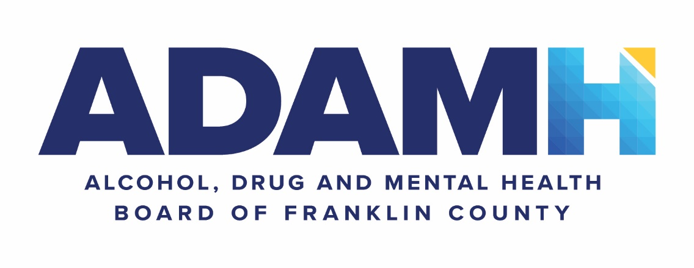

Request for Information

Cloud Migration Vendor

Released Friday, July 22, 2022
Due Friday, August 19, 2022

I. EXECUTIVE SUMMARY

A. Purpose

The ADAMH Board of Franklin County seeks a vendor to help ADAMH move all existing infrastructure from 447 East Broad Street into a proper cloud service data center. ADAMH has determined that the cost to hire a staff to support, purchase equipment and services to mitigate all single sources of failure would be cost prohibitive to the organization.

B. Organization Background and Overview

The ADAMH Board leads the planning, funding, and evaluation of community-based recovery-oriented mental health and addiction prevention, treatment, and support services for residents of Franklin County. ADAMH does not provide any direct services, but instead partners with more than 30 non-profit agencies to ensure that all individuals and families in Franklin County achieve optimal mental health and wellness, free from stigma, with equitable access to quality community-based services and supports.

ADAMH receives funding from the following three key sources: federal dollars, state departments, and a local property tax levy. A five-year, 2.2 mil property tax levy makes up almost 70 percent of ADAMH’s total annual funding. The last levy was approved by 70 percent of Franklin County voters in 2020 and is effective 2022-2026. ADAMH is guided by an 18-member board of trustees that is appointed by the Ohio Department of Mental Health and Addiction Services or the Franklin County Board of Commissioners.

ADAMH is committed to ensuring that diversity and inclusion values are considered in all aspects of the board’s procurement processes. To that end, ADAMH encourages the participation and inclusion of minority, women, disadvantaged, and veteran business enterprises.

C. Non-discrimination

It is the policy of the ADAMH Board to follow the laws and executive orders relevant to equal employment opportunity. Therefore, no qualified person will be discriminated against in recruitment, appointment, promotion, retention, or any other aspect of personnel administration, based on race, color, religion, age, gender, disability, military status, national origin, sexual orientation, or genetic information.

The vendor will take affirmative action to ensure that applicants are employed and that employees are treated during employment without regard to race, color, religion, age, gender, disability, military status, national origin, sexual orientation, or genetic information. Such action shall include, but not be limited to, employment, upgrading, promotion, demotion, termination, rates of pay, or other forms of compensation, and selection for training. The vendor agrees to post in conspicuous places, available to employees and applicants for employment, notices summarizing the provisions of this equal opportunity clause. The vendor, in all solicitations or advertisements for employees placed by, or on behalf of the vendor, state that they are an equal opportunity employer.

D. Goals and Objectives of This Request

The purpose of this request is to identify vendors to receive a request for proposals. Once all responses to this request for information are received and scored, ADAMH will decide which cloud service providers will be requested to respond to that RFP. The date to distribute the RFP is still to be determined.

This request for information is not considered to be a contract or an agreement by ADAMH to engage any cloud service provider for services. The purpose of this document and attached questionnaire along with an RFP is to gather information that ADAMH will consider for awarding a contract to a cloud service provider.

E. Calendar of Events and Project Timetable

To receive full consideration, applicants should submit the completed questionnaire by noon on Monday, August 19, 2022 to the RFPsubmission@adamhfranklin.org inbox.

ADAMH, at its discretion may terminate the search for a cloud service provider at any time during this process without further consideration.

II. SCOPE OF WORK

The ADAMH technology infrastructure exists in the basement of 447 East Broad Street in Columbus, Ohio. The technology infrastructure has supported the needs of the agency in its existing location for many years. After careful evaluation, the agency has determined that the technology infrastructure has several deficiencies that, if remediated, would provide a more stable and operationally efficient environment for ADAMH technology users. Examples of deficiencies include single point of failures such as single electricity provider and entrance facility, single internet service provider, no hardware failover, no generator or alternative source of power in the event of a power outage and limited UPS run time.

This RFI along with the associated RFP will provide ADAMH with documentation and associated costs that will resolve defined single points of failure along with additional software, hardware, support and data center services. Chosen vendor will be expected to provide the following services, although this is not an all-inclusive list:

Software services:
- Licensing
- Cyber threat protection
- Upgrades
- Patching services
- Maintenance
- Support services

Hardware services:
- Failover redundancy
- Upgrade/EOL schedule
- Cyber threat protection
- Firmware/driver upgrade
- Failure/degradation detection and remediation
- Availability SLA

Support services:
- Ticketing system
- Escalation process
- 24 x 7 support
- Trouble priority/severity
- Response SLA
- Change management
Data center services:
- Multiple ISP’s
- Diverse power feeds
- Redundant UPS/HVAC
- Facility physical security
- Hot/cold aisles
- Rack access protection
- Backup power source

III. SUBMISSION REQUIREMENTS

Please respond to include all the information as written in this section.

A. Questionnaire

ADAMH has attached a questionnaire that potential cloud solution providers are being asked to fill out. While most questions could be answered with a simple yes or no, ADAMH would expect potential cloud solution providers to add additional context to ensure ADAMH is aware of all solutions the cloud provider would like known. Potential cloud service providers at any time may reach out to ADAMH via email at RFPsubmission@adamhfranklin.org for clarification or additional understanding of any question. ADAMH may respond either via email or may schedule a meeting to ensure the request is fully understood and responded to in a reasonable time frame.

